Dim:

TARGET:

CREATE TABLE target_a(

[EmployeeKey] [int] IDENTITY(1,1),

[ParentEmployeeKey] [int] NULL,

[Name] [nvarchar](50) NULL,

[HireDate] [nvarchar](50) NULL,

[Birthdate] [nvarchar](50) NULL,

[LoginID] [nvarchar](256) NULL,

[EmailAddress] [nvarchar](50) NULL,

[PhoneNo] [nvarchar](50) NULL,

[MaritalStatus] [nchar](10) NULL,

[Gender] [nchar](10) NULL,

[DepartmentName] [nvarchar](50) NULL

) ON [PRIMARY]

GO

--------------------------------------------------------------------------------------

INSERT INTO TARGET:

INSERT INTO target_a (ParentEmployeeKey,Name,HireDate,Birthdate,LoginID,EmailAddress,PhoneNo,MaritalStatus,Gender,DepartmentName )

SELECT E.[EmployeeID],(C.[FirstName]+' ' + C.[LastName]) NAME,

FORMAT(E.[HireDate],'dd-MMM-yyyy') DATEA,

FORMAT(E.[BirthDate],'dd-MMM-yyyy') DATAW,

CONCAT(SUBSTRING(C.[LastName],1,1),C.[FirstName]) CNAME,

ISNULL(C.[EmailAddress],'N/A')EA,

CASE WHEN PHONE like ('[0-9][0-9][0-9]-[0-9][0-9][0-9]-[0-9][0-9][0-9][0-9]') THEN PHONE

ELSE 'N/A' END AS PhoneNo,

CASE WHEN E.[MaritalStatus]='S' then 'Single'

WHEN E.[MaritalStatus]='M' then 'Married'

else 'N/A'

end as MaritalStatus,

CASE WHEN E.[Gender]='M' then 'Male'

WHEN E.[Gender]='F' then 'Female'

else 'N/A'

end as Gender,

isnull(D.[Name],'N/A')DNAME

FROM [BCMPQA].[Contact] C JOIN [BCMPQA].[Employee] E ON C.[ContactID]=E.[ContactID]

JOIN [BCMPQA].[EmployeeDepartmentHistory] H ON H.[EmployeeID]=E.[EmployeeID]

JOIN [BCMPQA].[Department] D ON D.[DepartmentID]=H.[DepartmentID]

SOURCE

SELECT E.[EmployeeID],(C.[FirstName]+' ' + C.[LastName]) NAME,

FORMAT(E.[HireDate],'dd-MMM-yyyy') DATEA,

FORMAT(E.[BirthDate],'dd-MMM-yyyy') DATAW,

CONCAT(SUBSTRING(C.[LastName],1,1),C.[FirstName]) CNAME,

ISNULL(C.[EmailAddress],'N/A')EA,

CASE WHEN PHONE like ('[0-9][0-9][0-9]-[0-9][0-9][0-9]-[0-9][0-9][0-9][0-9]') THEN PHONE

ELSE 'N/A' END AS PhoneNo,

CASE WHEN E.[MaritalStatus]='S' then 'Single'

WHEN E.[MaritalStatus]='M' then 'Married'

else 'N/A'

end as MaritalStatus,

CASE WHEN E.[Gender]='M' then 'Male'

WHEN E.[Gender]='F' then 'Female'

else 'N/A'

end as Gender,

isnull(D.[Name],'N/A')DNAME

FROM [BCMPQA].[Contact] C JOIN [BCMPQA].[Employee] E ON C.[ContactID]=E.[ContactID]

JOIN [BCMPQA].[EmployeeDepartmentHistory] H ON H.[EmployeeID]=E.[EmployeeID]

JOIN [BCMPQA].[Department] D ON D.[DepartmentID]=H.[DepartmentID]

-------------------------------------------------------------

***''row count check''*****

(CHECK FOR BOTH SOURCE AND TARGET)

select COUNT(*)

FROM

(

SELECT E.[EmployeeID],(C.[FirstName]+' ' + C.[LastName]) NAME,

FORMAT(E.[HireDate],'dd-MMM-yyyy') DATEA,

FORMAT(E.[BirthDate],'dd-MMM-yyyy') DATAW,

CONCAT(SUBSTRING(C.[LastName],1,1),C.[FirstName]) CNAME,

ISNULL(C.[EmailAddress],'N/A')EA,

CASE WHEN PHONE like ('[0-9][0-9][0-9]-[0-9][0-9][0-9]-[0-9][0-9][0-9][0-9]') THEN PHONE

ELSE 'N/A' END AS PhoneNo,

CASE WHEN E.[MaritalStatus]='S' then 'Single'

WHEN E.[MaritalStatus]='M' then 'Married'

else 'N/A'

end as MaritalStatus,

CASE WHEN E.[Gender]='M' then 'Male'

WHEN E.[Gender]='F' then 'Female'

else 'N/A'

end as Gender,

isnull(D.[Name],'N/A')DNAME

FROM [BCMPQA].[Contact] C JOIN [BCMPQA].[Employee] E ON C.[ContactID]=E.[ContactID]

JOIN [BCMPQA].[EmployeeDepartmentHistory] H ON H.[EmployeeID]=E.[EmployeeID]

JOIN [BCMPQA].[Department] D ON D.[DepartmentID]=H.[DepartmentID]

)SRC

SELECT COUNT(*) FROM target_a;

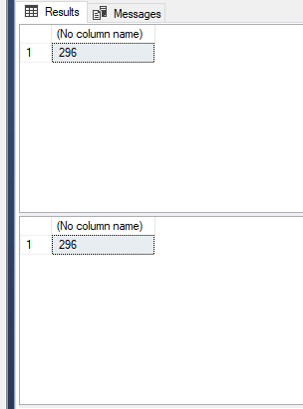

---------------------------------------------------------

****ROW COUNT CHECK GROUP BY****

( CHECK FOR BOTH SOURCE AND TARGET)

select EmployeeID, COUNT(*)

FROM

(

SELECT E.[EmployeeID],(C.[FirstName]+' ' + C.[LastName]) NAME,

FORMAT(E.[HireDate],'dd-MMM-yyyy') DATEA,

FORMAT(E.[BirthDate],'dd-MMM-yyyy') DATAW,

CONCAT(SUBSTRING(C.[LastName],1,1),C.[FirstName]) CNAME,

ISNULL(C.[EmailAddress],'N/A')EA,

CASE WHEN PHONE like ('[0-9][0-9][0-9]-[0-9][0-9][0-9]-[0-9][0-9][0-9][0-9]') THEN PHONE

ELSE 'N/A' END AS PhoneNo,

CASE WHEN E.[MaritalStatus]='S' then 'Single'

WHEN E.[MaritalStatus]='M' then 'Married'

else 'N/A'

end as MaritalStatus,

CASE WHEN E.[Gender]='M' then 'Male'

WHEN E.[Gender]='F' then 'Female'

else 'N/A'

end as Gender,

isnull(D.[Name],'N/A')DNAME

FROM [BCMPQA].[Contact] C JOIN [BCMPQA].[Employee] E ON C.[ContactID]=E.[ContactID]

JOIN [BCMPQA].[EmployeeDepartmentHistory] H ON H.[EmployeeID]=E.[EmployeeID]

JOIN [BCMPQA].[Department] D ON D.[DepartmentID]=H.[DepartmentID]

)SRC

group by EmployeeID

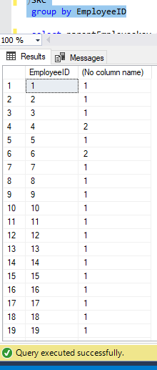

Target

select parentEmployeekey,COUNT(*)

from target_a

group by parentEmployeekey;

-------------------------------------------------------------

***DISTINCT/DUPLICATE RECORD CHECK***

(ONLY FOR TARGET)

select DepartmentName, COUNT(*)

FROM target_a

group by DepartmentName

HAVING COUNT(*)>1

-----------------------------------------------

Column level check(target left join source)

SELECT COUNT(*)

FROM target_a TGT

LEFT JOIN

(SELECT E.[EmployeeID],(C.[FirstName]+' ' + C.[LastName]) NAME,

FORMAT(E.[HireDate],'dd-MMM-yyyy') DATEA,

FORMAT(E.[BirthDate],'dd-MMM-yyyy') DATAW,

CONCAT(SUBSTRING(C.[LastName],1,1),C.[FirstName]) CNAME,

ISNULL(C.[EmailAddress],'N/A')EA,

CASE WHEN PHONE like ('[0-9][0-9][0-9]-[0-9][0-9][0-9]-[0-9][0-9][0-9][0-9]') THEN PHONE

ELSE 'N/A' END AS PhoneNo,

CASE WHEN E.[MaritalStatus]='S' then 'Single'

WHEN E.[MaritalStatus]='M' then 'Married'

else 'N/A'

end as MaritalStatus,

CASE WHEN E.[Gender]='M' then 'Male'

WHEN E.[Gender]='F' then 'Female'

else 'N/A'

end as Gender,

isnull(D.[Name],'N/A')DNAME

FROM [BCMPQA].[Contact] C JOIN [BCMPQA].[Employee] E ON C.[ContactID]=E.[ContactID]

JOIN [BCMPQA].[EmployeeDepartmentHistory] H ON H.[EmployeeID]=E.[EmployeeID]

JOIN [BCMPQA].[Department] D ON D.[DepartmentID]=H.[DepartmentID]

)SRC

ON TGT.ParentEmployeeKey=SRC.EmployeeID

WHERE

src.EmployeeID is null and(

TGT.ParentEmployeeKey<>SRC.EmployeeID or

(TGT.Name<>SRC.NAME)

OR

(TGT.HireDate<>SRC.DATEA)

OR

(TGT.Birthdate<>SRC.DATAW)

OR

(TGT.LoginID<>SRC.CNAME)

OR

(TGT.EmailAddress<>SRC.EA)

OR

(TGT.PhoneNo<>SRC.PhoneNo )

OR

(TGT.MaritalStatus<>SRC.MaritalStatus)

OR

(TGT.Gender<>SRC.Gender)

OR

(TGT.DepartmentName<>SRC.DNAME));

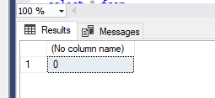

-------------------------------------------------------------------------------------------------------------------------------------

Fact:

target

create table target_b(

EmployeeKey int DEFAULT -1,

TimeKey int DEFAULT -1,

CalendarYear char(30) DEFAULT 'N/A',

CalendarQuarter INT DEFAULT -1,

Quantity int,

Unit_Price money,

salesAmount money DEFAULT 0

);

Insert into target

INSERT INTO target_b

select d.[EmployeeKey] AS EmployeeKey,

t.[TimeKey] AS TimeKey ,

t.[CalendarYear] AS CalendarYear ,

t.[CalendarQuarter] AS CalendarQuarter,

s.[Quantity] AS Quantity,

s.[Unit_Price] AS Unit_Price,

s.[SalesAmount] AS salesAmount

from

[BCMPQA].[Sales_Quota] s join [BCMPQA].[DimEmployee] d

on

d.[ParentEmployeeKey]=s.[EmployeeId]

join [BCMPQA].[DimTime] t on t.[FullDateAlternateKey]=s.[OrderDate]

--------------------------------------------------------------------

row count check

SELECT COUNT(*)

FROM

(select d.[EmployeeKey] AS EmployeeKey,

t.[TimeKey] AS TimeKey ,

t.[CalendarYear] AS CalendarYear ,

t.[CalendarQuarter] AS CalendarQuarter,

s.[Quantity] AS Quantity,

s.[Unit_Price] AS Unit_Price,

s.[SalesAmount] AS salesAmount

from

[BCMPQA].[Sales_Quota] s join [BCMPQA].[DimEmployee] d

on

d.[ParentEmployeeKey]=s.[EmployeeId]

join [BCMPQA].[DimTime] t on t.[FullDateAlternateKey]=s.[OrderDate])SRC

target:

SELECT COUNT(*) FROM target_b

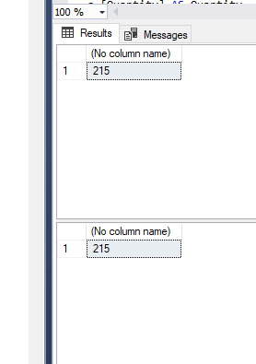

------------------------------------------------------

****Row count group by *****

source

SELECT EmployeeKey,COUNT(*)

FROM

(select d.[EmployeeKey] AS EmployeeKey,

t.[TimeKey] AS TimeKey ,

t.[CalendarYear] AS CalendarYear ,

t.[CalendarQuarter] AS CalendarQuarter,

s.[Quantity] AS Quantity,

s.[Unit_Price] AS Unit_Price,

s.[SalesAmount] AS salesAmount

from

[BCMPQA].[Sales_Quota] s join [BCMPQA].[DimEmployee] d

on

d.[ParentEmployeeKey]=s.[EmployeeId]

join [BCMPQA].[DimTime] t on t.[FullDateAlternateKey]=s.[OrderDate])SRC

GROUP BY EmployeeKey

Target

SELECT EmployeeKey,COUNT(*)

FROM target_b

GROUP BY EmployeeKey

-----------------------------------------------------------------------------

Reference integrity check (target left join source)

SELECT COUNT(*)

FROM

target_b TGT left join

(select d.[EmployeeKey] AS EmployeeKey,

t.[TimeKey] AS TimeKey ,

t.[CalendarYear] AS CalendarYear ,

t.[CalendarQuarter] AS CalendarQuarter,

s.[Quantity] AS Quantity,

s.[Unit_Price] AS Unit_Price,

s.[SalesAmount] AS salesAmount

from

[BCMPQA].[Sales_Quota] s join [BCMPQA].[DimEmployee] d

on

d.[ParentEmployeeKey]=s.[EmployeeId] JOIN [BCMPQA].[DimTime] t

on t.[FullDateAlternateKey]=s.[OrderDate]

)SRC

ON TGT.EmployeeKey =SRC.EmployeeKey

WHERE SRC.Employeekey is null

Stratification check

Source:

select sum(Quantity),sum(Unit_Price),sum(SalesAmount)

from(

select d.[EmployeeKey] AS EmployeeKey,

t.[TimeKey] AS TimeKey ,

t.[CalendarYear] AS CalendarYear ,

t.[CalendarQuarter] AS CalendarQuarter,

s.[Quantity] AS Quantity,

s.[Unit_Price] AS Unit_Price,

s.[SalesAmount] AS salesAmount

from

[BCMPQA].[Sales_Quota] s join [BCMPQA].[DimEmployee] d

on

d.[ParentEmployeeKey]=s.[EmployeeId] JOIN [BCMPQA].[DimTime] t

on t.[FullDateAlternateKey]=s.[OrderDate])src

target:

select sum(Quantity),sum(Unit_Price),sum(SalesAmount)

from target_b

------------------------------------------------------

Stratification check group by

Source:

select EmployeeKey,sum(Quantity),sum(Unit_Price),sum(SalesAmount)

from(

select d.[EmployeeKey] AS EmployeeKey,

t.[TimeKey] AS TimeKey ,

t.[CalendarYear] AS CalendarYear ,

t.[CalendarQuarter] AS CalendarQuarter,

s.[Quantity] AS Quantity,

s.[Unit_Price] AS Unit_Price,

s.[SalesAmount] AS salesAmount

from

[BCMPQA].[Sales_Quota] s join [BCMPQA].[DimEmployee] d

on

d.[ParentEmployeeKey]=s.[EmployeeId] JOIN [BCMPQA].[DimTime] t

on t.[FullDateAlternateKey]=s.[OrderDate])src

group by

EmployeeKey

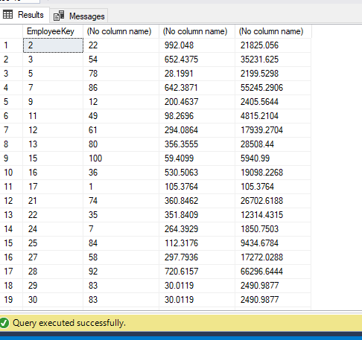

Target:

select EmployeeKey,sum(Quantity),sum(Unit_Price),sum(SalesAmount)

from target_b

group by EmployeeKey

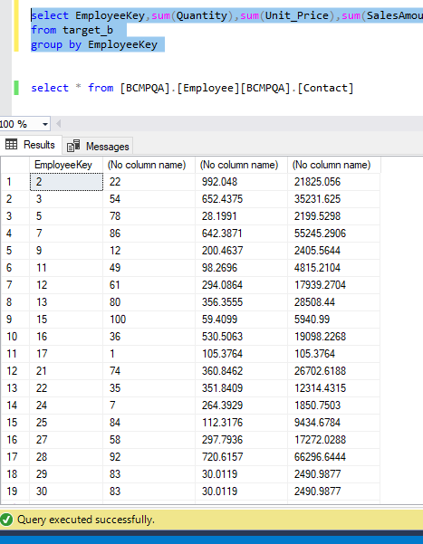

Informatica testing..

CREATE TABLE target_t_dim1(

[EmployeeKey] [int] IDENTITY(1,1),

[ParentEmployeeKey] [int] NULL,

[Name] [nvarchar](50) NULL,

[HireDate] [nvarchar](50) NULL,

[Birthdate] [nvarchar](50) NULL,

[LoginID] [nvarchar](50) NULL,

[EmailAddress] [nvarchar](50) NULL,

[PhoneNo] [nvarchar](50) NULL,

[MaritalStatus] [nchar](10) NULL,

[Gender] [nchar](10) NULL,

[DepartmentName] [nvarchar](50) NULL

) ON [PRIMARY]

GO

select * from target_t_dim1

TRUNCATE TABLE target_t_dim1